Stampin’ UP Wildflower Birthday Accordion Fun Fold Card Tutorial

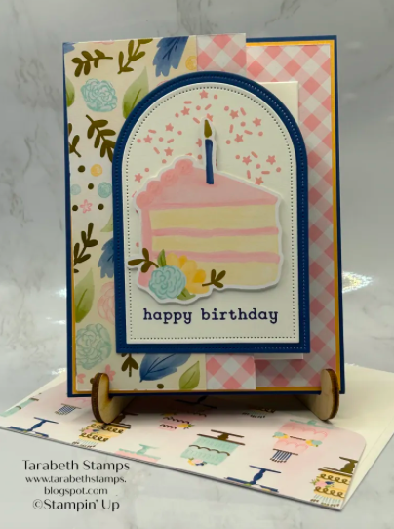

Supplies:
- Stampin’ Up Sweet Jar Stamp Set
- Stampin’ Up Arched Wishes Stamp Set
- Stampin’ Up Wildflower Birthday DSP
- Stampin’ Up Everyday Arches Dies
- Blueberry Bushel Cardstock
- Peach Pie Cardstock
- Basic White Cardstock
- Blueberry Bushel Ink Pad
- Pretty In Pink Ink Pad
- Stampin’ Dimensionals
- Adhesive of choice

Dimensions:
- Blueberry Bushel: 5 ½” x 4 ¼” and 3” x 4 ¼”
- Pretty In Pink: 5 3/8” x 4 1/8”
- DSP: 5 ¼” x 11 ½” scored at 4”, 6 ¾” and 9 ½”
- Basic White: 3” x 4 ¼” and 3” x 4 ¼”

Directions:
  - Score DSP along the 11 1/2” side at 4”, 6 ¾”, and 9 ½”. Fold DSP in a mountain valley mountain orientation.
  - Adhere the 2” portion of DSP to the 2 ¾” with adhesive of choice
  - Adhere DSP to 5 3/8” x 4 1/8” Peach Pie mat
  - Adhere layers to 5 ½” x 4 ¼” Blueberry Bushel
  - Die cut 3” x 4 ¼” Blueberry Bushel with 4th largest die from Everyday Arches Dies
  - Die cut 3” x 4 ¼” Basic White cardstock with 5th largest die
  - Stamp confetti from Arched Wishes Stamp Set randomly with Pretty In Pink on the Basic White die cut
  - Stamp sentiment from Sweet Jar Stamp Set with Blueberry Bushel ink
  - Adhere the Basic White die cut to the Blueberry Bushel die cut with adhesive of choice
  - Adhere die-cut layers to the card front using adhesive of choice (be sure only to apply adhesive to the left side)
  - Adhere the die cut from Wildflower Birthday DSP to the card front with Stampin’ Dimensionals
  - Stamp sentiment from Sweet Jar Stamp Set using Blueberry Bushel ink on 3” x 4 ¼” Basic White cardstock
  - Adhere the stamped panel to the inside of the card base

